## What are Keys in DBMS?

**KEYS in DBMS** is an attribute or set of attributes which helps you to identify a row(tuple) in a relation(table). They allow you to find the relation between two tables.

RDB - Relational Databases

RDBMS - Relational Database Management System

- eg : Oracle, Postgres, SQLServer, MySql etc

databases, tables, rows/records, columns

student_details(table)

stud_id stud_name stud_mark

101 ABC 60

102 XYZ 50

SQL - Structured Querying Language,

- compiled and executed

ANSII SQL - standard followed by all sql DB software vendors

dialect – minor changes in queries with different types of software or database

ORM - Object Relational Mapping (don’t have to worry about this in week2) -Spring Data, Hibernate, Ibatis

References

https://www.postgresqltutorial.com/

https://www.postgresql.org/docs/current/tutorial-table.html

https://www.simplilearn.com/tutorials/sql-tutorial/what-is-normalization-in-sql#:~:text=Normalization%20is%20the%20process%20to,data%20from%20the%20relational%20tables.

So, in summary, the different types of database keys are:

Natural key: an attribute that can uniquely identify a row, and exists in the real world.

Surrogate key: an attribute that can uniquely identify a row, and does not exist in the real world.

Composite key: more than one attribute that when combined can uniquely identify a row.

Primary key: the single unique identifier for the row.

Candidate key: an attribute that could be the primary key.

Alternate key: a candidate key that is not the primary key.

Unique key: an attribute that can be unique on the table. Can also be called an alternate key.

Foreign key: an attribute that is used to refer to another record in another table.

student_details

student_id(PK)

101

102

103

course_details

course_id(PK)

501

502

503

student_course_details

stud_id course_id id🡨-----surrogate key

101 502 1

101 503 2

102 501 3

102 502 4

103 501 5

103 503 6

stud_id course_id

1st Normal Form (NF)

* A table is referred to as being in its First Normal Form if atomicity of the table is 1.
* Here, atomicity states that a single cell cannot hold multiple values. It must hold only a single-valued attribute.

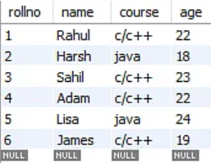

So we have to change above table to below table because above table contains multiple values in column to make it 1st NF.

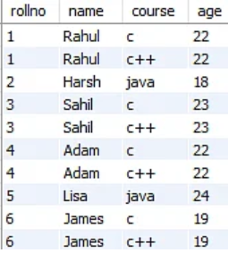

2nd normal form

Partial dependency means when we have composite primary key and then non-key values partial dependent on composite primary key is called partial dependency.

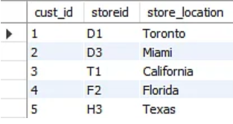

Composite Primary key = cust_id and storeid

Non-key = store_Loation

Now store location is only depends on storeid not on cust_id so it is partial depended so now we have to break the table to make fully depended on primary key

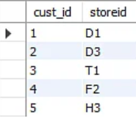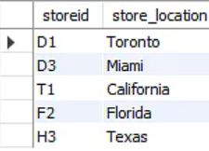

Another example for 2nd normal form

employee_project_details

emp_id(PK) , proj_id(PK), emp_name, proj_description, proj_rate

project rate depends on project_id(what kind of project is that) as well as employ_id( manager, dev, tester) so new table below proj_rate is fully depends on composite primary key

emp_id(PK), proj_id(PK), proj_rate

emp_name is depends on emp_id not on proj_id so new table below

emp_id, emp_name

proj_description depends on proj_id not on emp_id so new table below

proj_id, proj_description

3rd normal form

No Transitive dependency

A🡪B and B🡪C

A🡪C indirectly

So we have to remove transitive dependency to make 3rd NF

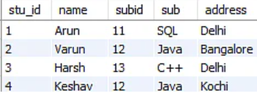

In the aove table stu_id is PK and we can find subid with stu_id (means A🡪B)

And subid can find sub (B🡪C)

And sub is not dependent on stu_id (PK)

So we have to remove transitive dependency

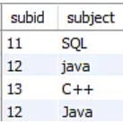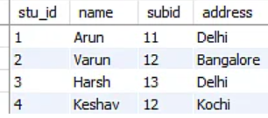

**BCNF boyce codeNormal Form**

Boyce Codd Normal Form is also known as 3.5 NF. It is the superior version of 3NF a

every Right-Hand Side (RHS) attribute of the functional dependencies should depend on the super key of that particular table.

Joins

When we are dividing data or create smaller tables to make it normalization form then it would become difficult to fetch all data related to one particular row. As a result of which, we are using joins. But too many joins also reduce performance of query.

We are also renormalize to reduce number of small table so it can’t lower performance of join query as a result we compromise with normalization not with performance of join query. Means we go with denormalization

HomeWork

2 types of functions

scalar function

- work on individual record

aggregate function

- works on all the record in one go

4 things that a client to contact the server

- protocol – rules or English language two way so they can understand each other

- ip address

- port

- credententials if it is secured

- network

meta commands in postgres

--------------------------

\l - lists all the databases

\dt - list all the tables in the current database that you are connected to

\c - connect to a particular database

GENERATED ALWAYS AS IDENTITY- used to generate automatically primary key

Create database sms

\c sms - to connect to sms database

CREATE TABLE product_details(product_id int PRIMARY KEY GENERATED ALWAYS AS IDENTITY, product_name varchar(25), product_description varchar(200), product_cost int, product_image_url varchar(255));

Select * from product_details;

INSERT INTO product_details(product_name, product_description, product_cost) VALUES(‘Apples’, ‘Juicy Apples’, 15, ‘ ’);

Select * from product_details;

INSERT INTO product_details(product_name, product_description, product_cost) VALUES(‘Bananas’, ‘Delicious Bananas’, 17, ‘’);

Primary key - 2 types to use column constraint and table constraint

* + - 1. Can’t be null
      2. Must be unique
      3. When you make any column as primary key that column is automatically indexed. Which would take extra memory to store indexed files which slows down the speed and process of insertion. Because they have to added to index too.

Disable contraints – when we take a back up of database because constraints slows down the speed of execution as its just copy functions. After copy DB enable it again

\c sample

\dt

CREATE TABLE employee_deatils(emp_id int, emp_name VARCHAR(20), emp_salary int, PRIMARY KEY (emp_id));

CREATE TABLE department_details(dept_id int, dept_name VARCHAR (20), PRIMARY KEY (dept_id));

DROP TABLE employee_details;

CREATE TABLE employee_details(emp_id INT, dept_id INT, emp_name VARCHAR(20), emp_salary INT, PRIMARY KEY (emp_id), FOREIGN KEY (dept_id) REFERENCES department_details(dept_id));

INSERT INTO department_details VALUES (501, ‘HR‘ );

INSERT INTO department_details VALUES (502, ‘IT Development‘ );

INSERT INTO department_details VALUES (503, ‘QA‘ ) (504, ‘Tester‘ );

INSERT INTO employee_details values (101,501,'abc',7000),(102,502,'qwerty',7500),(103,503,'pqrs',8450),(104,504,'zinga la la',4578);

**JOINS**

If I want to fetch all data with emp_id(PK) then with the help of foreign key, we are able to fetch department name with joins. We can fetch all data from multiple tables

Cartesian product

If we have two tables

(A, B , C)

(K, L)

Then Cartesian product is below

(A,K) (A,L) (B,K) (B,L) (C,K) (C,L)

Depending on joining condition and join type that you specify that combination will be fetched

two styles to write joins

- theta style - old

- join style - new

SELECT emp_id, emp_name, emp_salary, dept_name FROM employee_details,department_details;

emp_id | emp_name | emp_salary | dept_name

--------+-------------+------------+----------------

101 | abc | 7000 | HR

102 | qwerty | 7500 | HR

103 | pqrs | 8450 | HR

104 | zinga la la | 4578 | HR

101 | abc | 7000 | IT Development

102 | qwerty | 7500 | IT Development

103 | pqrs | 8450 | IT Development

104 | zinga la la | 4578 | IT Development

101 | abc | 7000 | QA

102 | qwerty | 7500 | QA

103 | pqrs | 8450 | QA

104 | zinga la la | 4578 | QA

101 | abc | 7000 | Scrum Master

102 | qwerty | 7500 | Scrum Master

103 | pqrs | 8450 | Scrum Master

104 | zinga la la | 4578 | Scrum Master

(16 rows)

SELECT emp_id, emp_name, emp_salary, dept_name FROM employee_details,department_details where employee_details.dept_id=department_details.dept_id;

emp_id | emp_name | emp_salary | dept_name

--------+-------------+------------+----------------

101 | abc | 7000 | HR

102 | qwerty | 7500 | IT Development

103 | pqrs | 8450 | QA

104 | zinga la la | 4578 | Scrum Master

(4 rows)

SELECT emp_id, emp_name, emp_salary, dept_name FROM employee_details emp INNER JOIN department_details dept ON emp.dept_id=dept.dept_id;

emp_id | emp_name | emp_salary | dept_name

--------+-------------+------------+----------------

101 | abc | 7000 | HR

102 | qwerty | 7500 | IT Development

103 | pqrs | 8450 | QA

104 | zinga la la | 4578 | Scrum Master

(4 rows)

Where emp is alisis

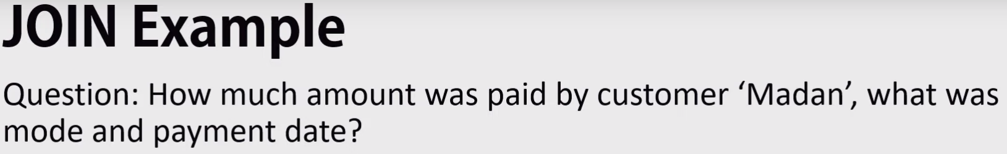

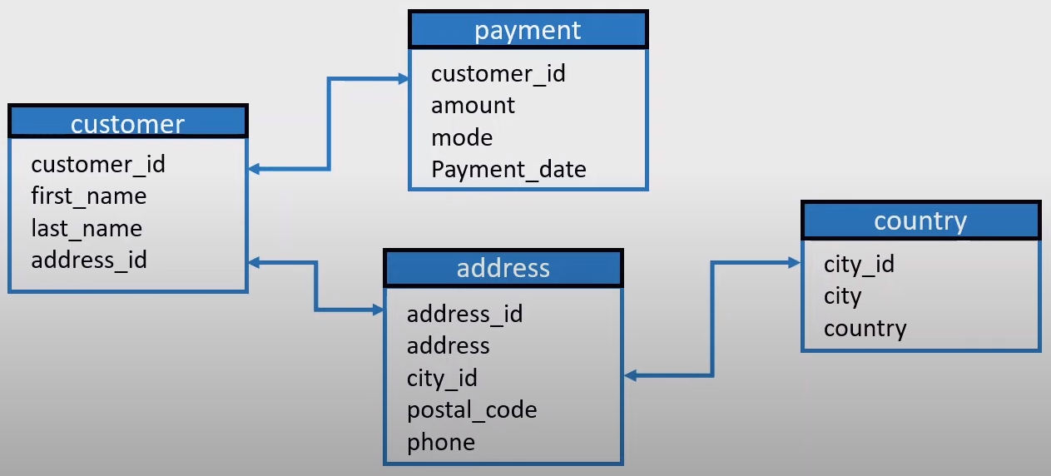

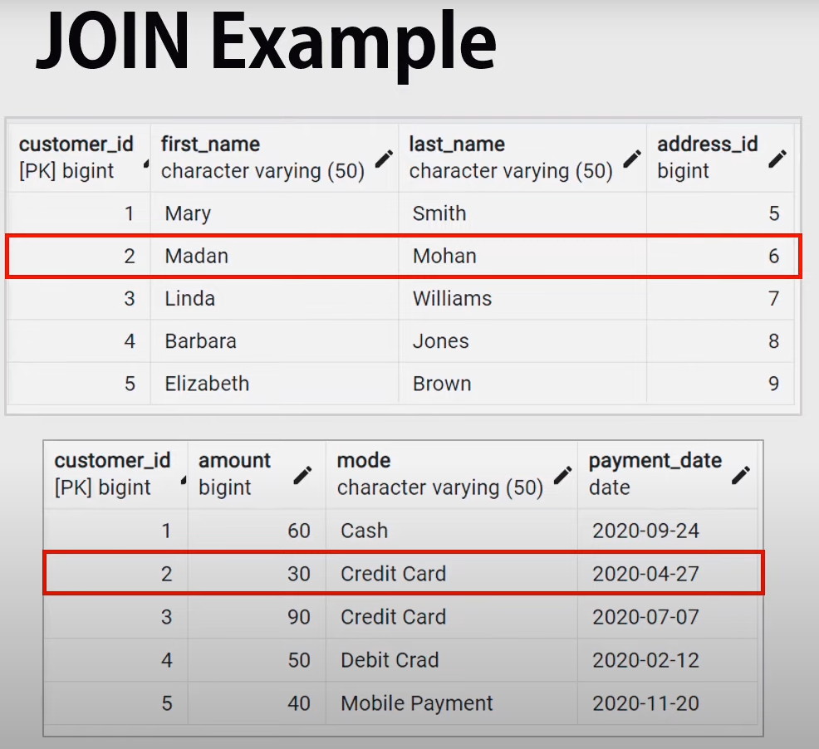

Inner Join

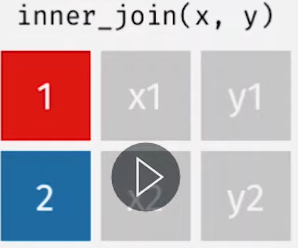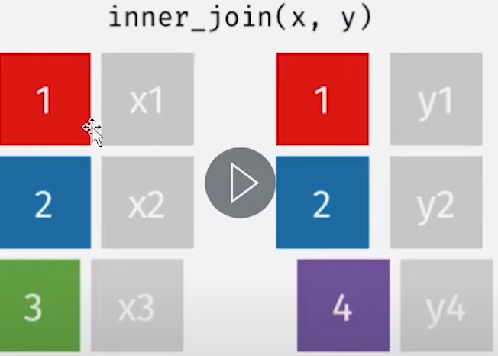

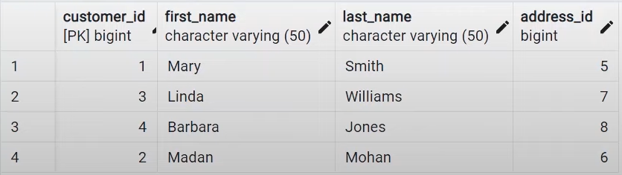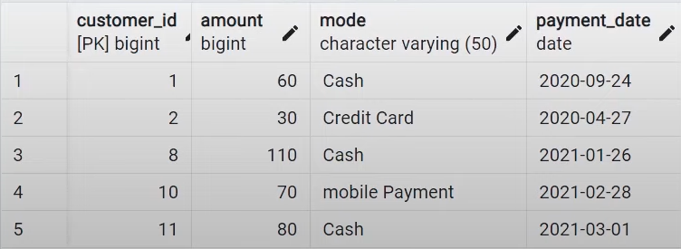

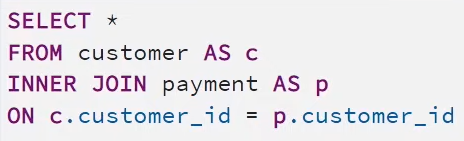

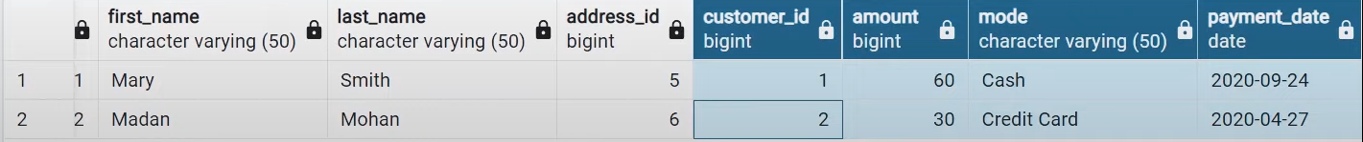

Left Join:

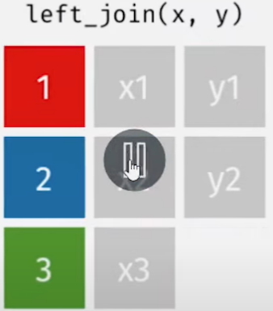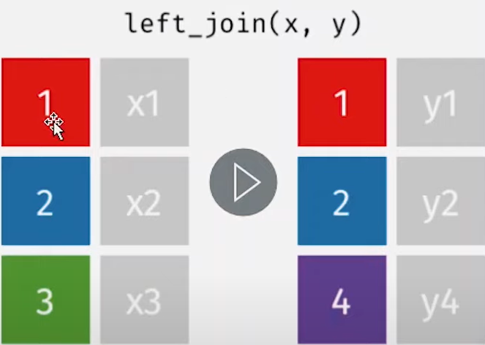

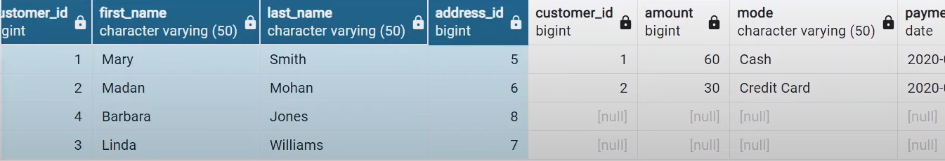

Right Join

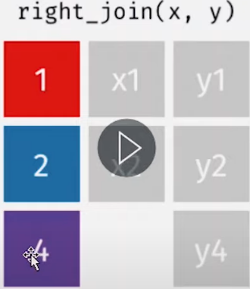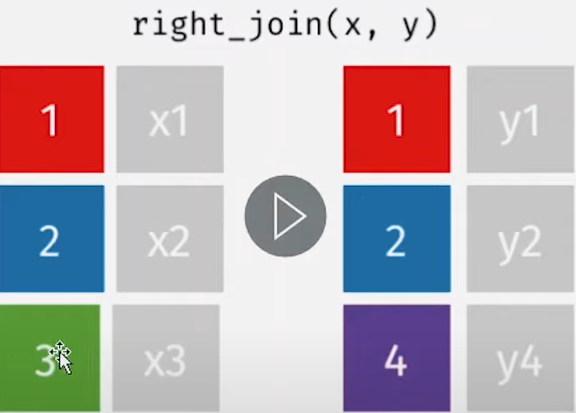

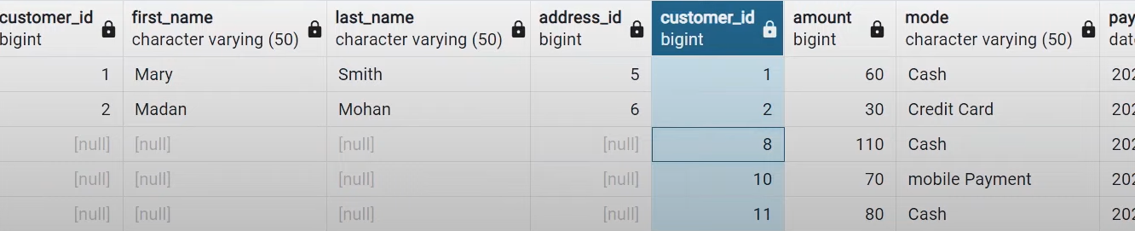

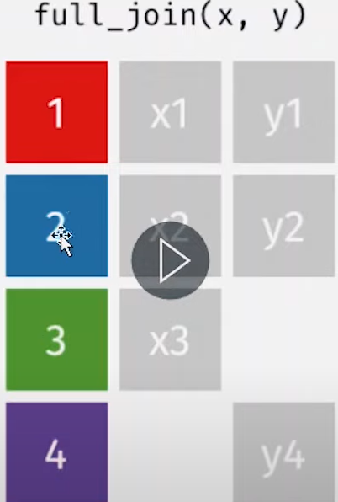

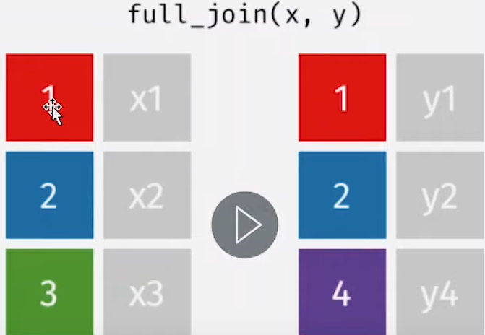

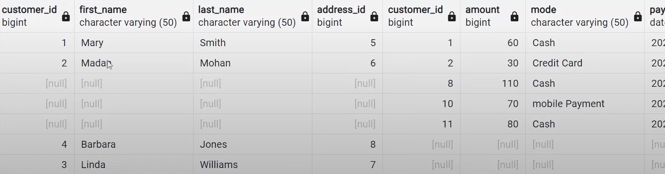

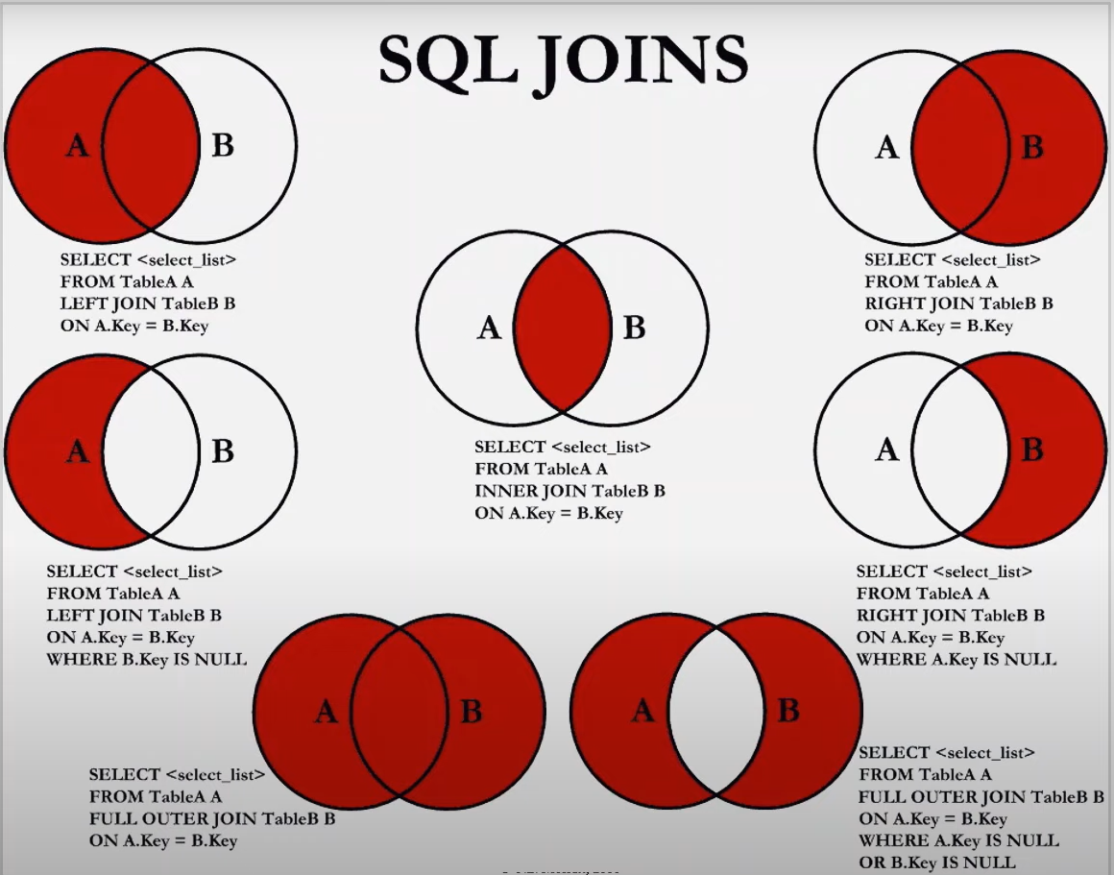

Self join example

-----------------

write a query to display employe names and the names of their manager

CREATE TABLE emp_manager_details(emp_id INT, emp_name VARCHAR(20), emp_salary INT, mgr_id INT, PRIMARY KEY(emp_id), FOREIGN KEY(mgr_id) REFERENCES emp_manager_details(emp_id));

INSERT INTO emp_manager_details VALUES(101,'ABC', 10000, 101);

INSERT INTO emp_manager_details VALUES(102,'XYZ', 8000, 101);

INSERT INTO emp_manager_details VALUES(103,'LMN', 8000, 101);

INSERT INTO emp_manager_details VALUES(104,'QWE', 8000, 102);

select * from emp_manager_details;

SELECT emp1.emp_name, emp2.emp_name manager_name FROM emp_manager_details emp1 INNER JOIN emp_manager_details emp2 ON emp1.mgr_id=emp2.emp_id;

emp_id emp_name mgr_id

101 ABC 103

102 XYZ 103

103 LMN 104

104 QWE 104

emp_id emp_name mgr_id

101 ABC 103

102 XYZ 103

103 LMN 104

104 QWE 104

boolean result=stmt.execute(query); - for DDL

int rows=stmt.executeUpdate(query); - for DML

ResultSet resultSet=stmt.executeQuery(query); - for DQL

\

working with statement

Statement stmt = conn.createStatement();

String query = "INSERT INTO product_details(product_name, product_description, product_cost, product_image_url) VALUES ('"+productPojo.getProductName()+"', '"+productPojo.getProductDescription()+"', "+productPojo.getProductCost()+", '')";

int rowsAffected = stmt.executeUpdate(query); // 1 Hit, 1 compilation, 1 execution

// total - 1H, 1C, 1E

// for 100 product insertions, analysis - 100 H, 100 compilation, 100 excecutions

working with prepared statement

- pre-compiled statements

- compiled once and executed many times

---------------------------------

PreparedStatement pstmt = con.prepareStatement("INSERT INTO product_details(product_name, product_description, product_cost, product_image_url) VALUES (?, ?, ?, ?)");// 1 Hit,1 Compilation

pstmt.setString(1, productPojo.getProductName());

pstmt.setString(2, productPojo.getProductDescription());

pstmt.setInt(3, productPojo.getProductCost());

pstmt.setString(4, "");

int rowsAffected = pstmt.executeUpdate();// 1 Hit, 1 Execution

// total - 2H, 1C, 1E

// for 100 product insertions, analysis - 101 H, 1 compilation, 100 excecutions

5 Categories of SQL queries

- DDL (Data Definition Language)

- deal with the structure of the table

- create, alter, drop, truncate

- DML (Data Manipulation La nguage)

- deal with the data in the table

- insert, update, delete

- TCL (Transaction Control language)

- commit, rollback, savepoints

Commands in PSQL – begin, commit, rollback.

conn.setAutoCommit(**false**); // marks the begining of the transaction

**int** rowsAffected1 = stmt.executeUpdate(query1);

// anything could happen here, maybe DB server is down or network is down

**int** rowsAffected2 = stmt.executeUpdate(query2);

conn.commit(); // makes the temporary changes permanent, marks the end of a successfull transaction

- DCL (Data Control language)

- granting and revoking priveliges to the users

- grant, revoke

Constraints are rules for data in tables

Normalization is a way to split raw data into multiple tables so we have consistent data in our hands

ACID properties for transactions -very strong interview question

ACID

A-antomicity

C-consistency

I-Isolation

PL/SQL - stored procedure, functions, triggers

Two types of functions in PSQL

Scaller Funtions

* Works on single row/tupple/record
* Moves rows/tuples one by one

Aggaregate Functions

* Works on multiple records
* - DQL (Data Querying Language)
* - select
* clause
* - projection
* - from clause
* - restriction - where clause
* - grouping
* - grouping restriction - having clause
* - order by clause

Projection means what you want to fetch

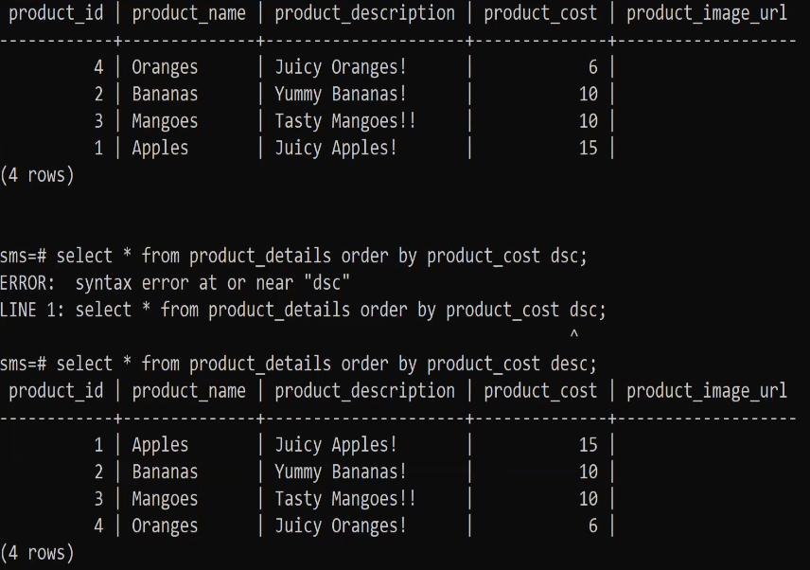

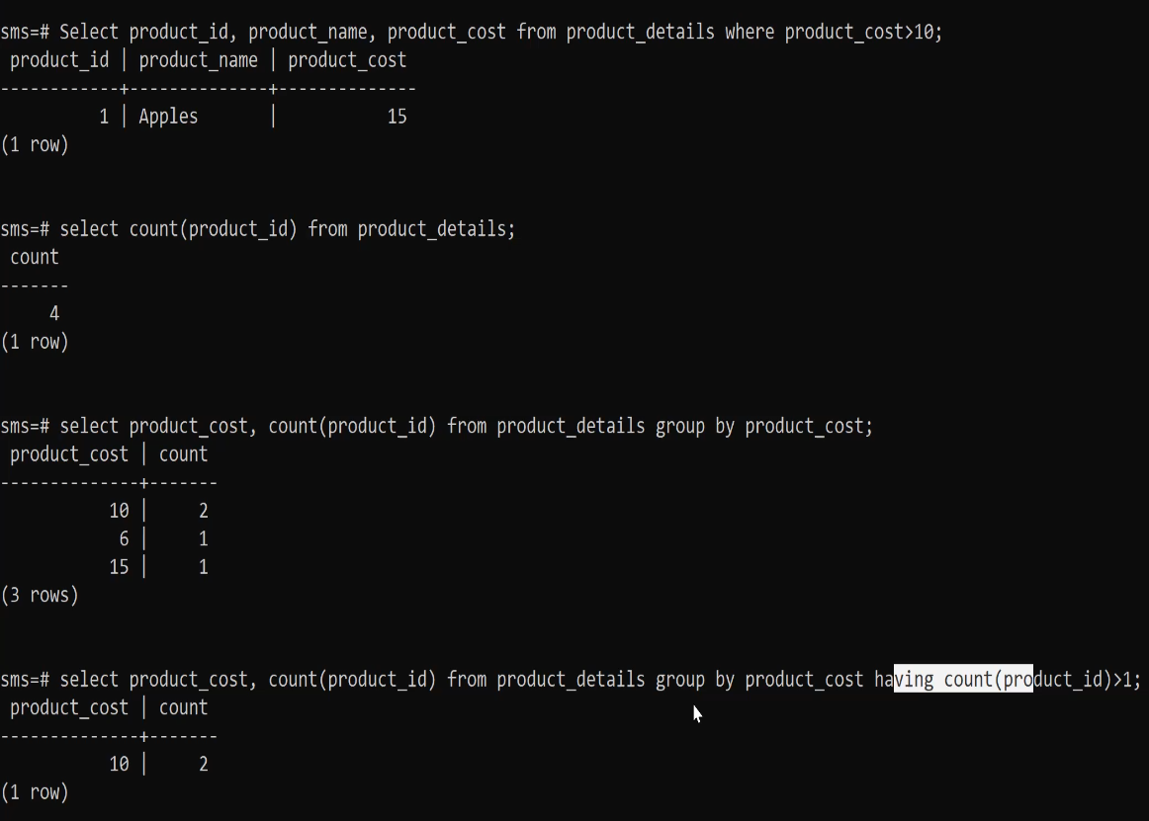

SubQuery – when a query works on an unknown value/ computed value, we use subquery to compute that value

* Inner query (sub query) and outer query
* First executes the subquery
* Secondly, gets the result and passes it to the outer query
* 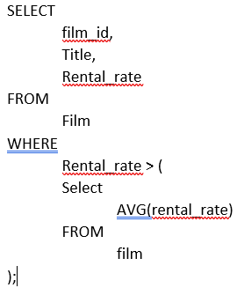Third, executes the outerquery.

For example

SELECT

film_id,

Title,

Rental_rate

FROM

Film

WHERE

Rental_rate > 2.8

Look For CORELLATED SUBQUERY and view

* For every record of the outer query, the inner query works

View – is giving name or reference to complex queries. So we can use that view name instead of wring complex queries again and again. It just kind for reference and It’s virtual

* Create View, Alter View and Drop View

Index-

* Used generally column which are frequently used in the where clause
* Will extra overhead but also improve efficiency
* Can create indexes on more than one column(may be where clause frequently works with those 2 columns together)
* Will takes extra memory. Its similar type od indexing like books topic name and page number
* Create Index, Alter Index and Drop Index

Clients

* pgAdmin
* db work